Name : Muhammad Rifqi Edrial

ERD
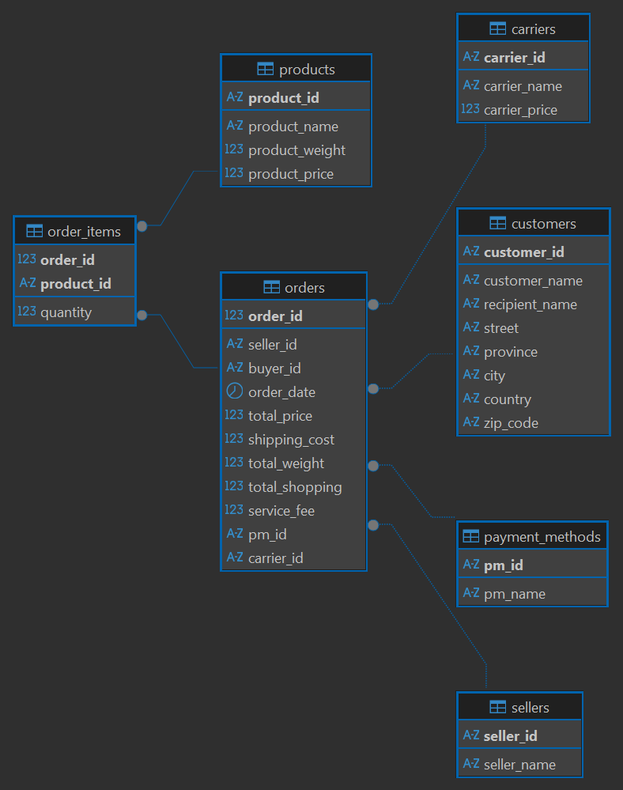
Gambar 1. ERD 3NF

SQL Queries
- Create Products Table
- CREATE TABLE products (
- product_id VARCHAR(10) PRIMARY KEY,
- product_name VARCHAR(100) NOT NULL,
- product_weight NUMERIC(10, 2) NOT NULL,
- product_price NUMERIC(15, 2) NOT NULL
- );

- Create Sellers Table
- CREATE TABLE sellers (
- seller_id VARCHAR(10) PRIMARY KEY,
- seller_name VARCHAR(100) NOT NULL
- );

- Create Customers Table
- CREATE TABLE customers (
- customer_id VARCHAR(10) PRIMARY KEY,
- customer_name VARCHAR(100) NOT NULL,
- recipient_name VARCHAR(100),
- street VARCHAR(150),
- province VARCHAR(100),
- city VARCHAR(100),
- country VARCHAR(100),
- zip_code VARCHAR(20)
- );

- Create Carriers Table

CREATE TABLE carriers (
carrier_id VARCHAR(10) PRIMARY KEY,
carrier_name VARCHAR(100) NOT NULL,
carrier_price NUMERIC(15, 2) NOT NULL
);

- Create payment_methods Table

CREATE TABLE payment_methods (
pm_id VARCHAR(10) PRIMARY KEY,
pm_name VARCHAR(100) NOT NULL
);

- Create Orders Table

CREATE TABLE orders (
order_id INTEGER PRIMARY KEY,
seller_id VARCHAR(10) NOT NULL REFERENCES sellers(seller_id),
buyer_id VARCHAR(10) NOT NULL REFERENCES customers(customer_id),
order_date DATE NOT NULL,
total_price NUMERIC(15, 2) NOT NULL,
shipping_cost NUMERIC(15, 2) NOT NULL,
total_weight NUMERIC(10, 2) NOT NULL,
total_shopping NUMERIC(15, 2) NOT NULL,
service_fee NUMERIC(15, 2) NOT NULL,
pm_id VARCHAR(10) NOT NULL REFERENCES payment_methods(pm_id),
carrier_id VARCHAR(10) NOT NULL REFERENCES carriers(carrier_id)
);

- Create order_item Table

CREATE TABLE order_items (
order_id INTEGER NOT NULL REFERENCES orders(order_id),
product_id VARCHAR(10) NOT NULL REFERENCES products(product_id),
quantity INTEGER NOT NULL,
PRIMARY KEY (order_id, product_id)
);

- Insert Into Products

INSERT INTO products (product_id, product_name, product_weight, product_price) VALUES
('P0001', 'Bola Basket Size 7', 2300, 177900),
('P0002', 'Bola Basket Size 5', 500, 98900),
('P0003', 'Pentil Pompa Bola', 54, 9900),
('P0004', 'Pompa Bola', 198, 43900),
('P0005', 'Apple Iphone Pro Max', 1000, 25000000),
('P0006', 'Apple Watch 8', 2000, 8000000);

- Insert Into Sellers

INSERT INTO sellers (seller_id, seller_name) VALUES
('S01', 'Galeri Olahraga'),
('S02', 'Hello Store');

- Insert Into Customers

INSERT INTO customers (customer_id, customer_name, recipient_name, street, province, city, country, zip_code) VALUES
('C01', 'Joko Morro', 'Budi Nugraha', 'Jalan raya xxx', 'DKI Jakarta', 'Jakarta', 'Indonesia', '433333'),
('C02', 'Eko Kurniawan', 'Rully', 'Jalan raya baru', 'Jawa Barat', 'Bandung', 'Indonesia', '432434');

- Insert Into Carriers

INSERT INTO carriers (carrier_id, carrier_name, carrier_price) VALUES
('CA01', 'Sicepat - Gokil', 1000),
('CA02', 'JNE', 1000);

- Insert Into payment_methods

INSERT INTO payment_methods (pm_id, pm_name) VALUES
('PM01', 'Debit Online'),
('PM02', 'Credit Card');

- Insert Into Orders

INSERT INTO orders (order_id, seller_id, buyer_id, order_date, total_price, shipping_cost, total_weight, total_shopping, service_fee, pm_id, carrier_id) VALUES
(12345, 'S01', 'C01', '2023-04-05', 508500, 60000, 5360, 568500, 1000, 'PM01', 'CA01'),
(11111, 'S02', 'C02', '2023-04-06', 33000000, 100000, 2000, 33100000, 1000, 'PM02', 'CA02'),
(22222, 'S01', 'C01', '2023-04-07', 355800, 60000, 2300, 415800, 1000, 'PM01', 'CA01');

- Insert Into order_items

INSERT INTO order_items (order_id, product_id, quantity) VALUES
(12345, 'P0001', 2),
(12345, 'P0002', 1),
(12345, 'P0003', 1),
(12345, 'P0004', 1),
(11111, 'P0005', 1),
(11111, 'P0006', 1),
(22222, 'P0001', 2);

